CSA1708-ARTIFICIAL INTELLIGENCE
LAB EXPERIMENTS
Program 5 : Python Program for Missionaries and Cannibals Problem
Aim
To develop a Python program that solves the Missionaries and Cannibals Problem using Breadth-First Search (BFS) to safely transport 3 missionaries and 3 cannibals across a river without violating safety constraints.
Algorithm
1. Represent the state as a tuple (M, C, B) denoting the number of missionaries and cannibals on the starting (left) bank and the position of the boat (1 = starting bank, 0 = destination bank).
2. Define the initial state as (3, 3, 1) and the goal state as (0, 0, 0).
3. Define the validity constraints: for both banks, missionaries must never be outnumbered by cannibals unless there are zero missionaries: (M == 0 or M >= C) and ((3 - M) == 0 or (3 - M) >= (3 - C)), with 0 <= M <= 3 and 0 <= C <= 3.
4. Define allowable boat moves with at most 2 passengers: (1, 0), (2, 0), (0, 1), (0, 2), (1, 1).
5. Initialize a BFS queue containing the initial state and an empty move path, and mark the initial state as visited.
6. While the queue is not empty, dequeue the current state and path:
7. a. If the goal state (0, 0, 0) is reached, return the sequence of states and actions.
8. b. If the boat is on the starting bank (B = 1), compute next states by subtracting passengers from the left bank.
9. c. If the boat is on the destination bank (B = 0), compute next states by adding passengers to the left bank.
10. d. For each resulting valid, unvisited state, add it to the visited set and enqueue it.
11. Display the step-by-step river crossing operations from start to goal.

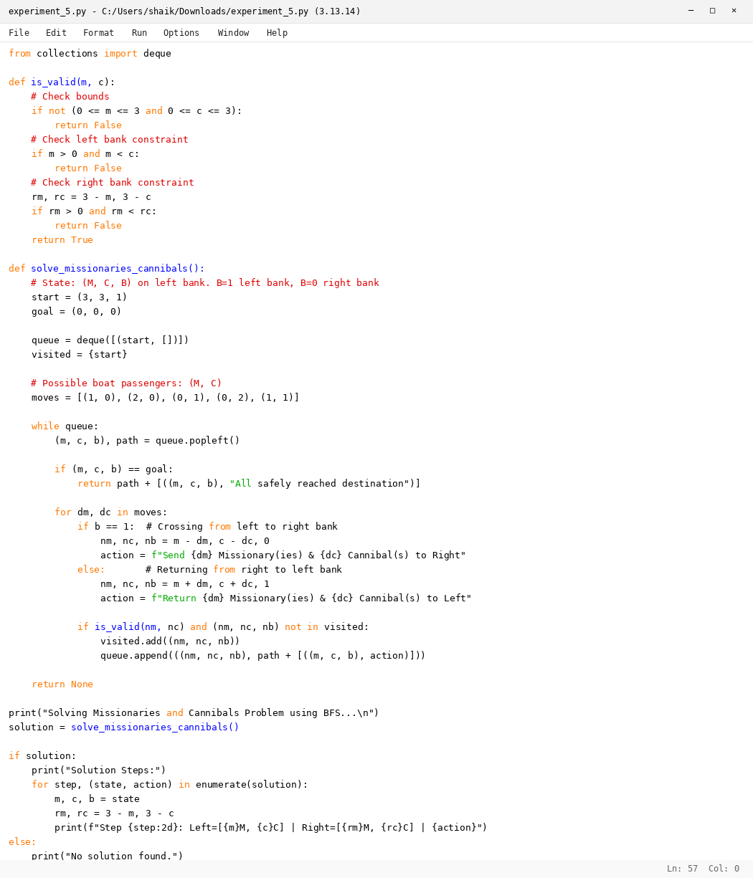

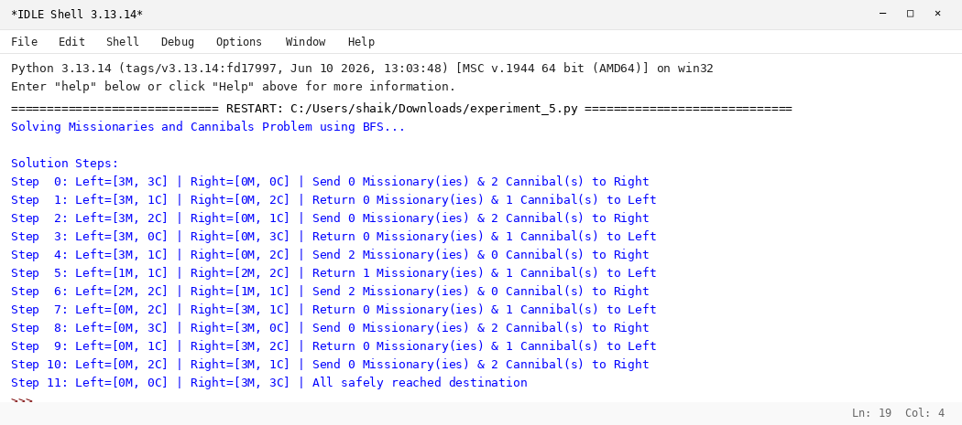

RESULT
Thus, the Missionaries and Cannibals Problem was solved successfully using Python.

